English News Summary
Ikea Customers trapped after Blizzard

On 2 December 10.42 AM
Danish Ikea Customers were shopping in the big furniture shop when suddenly a snowstorm arrived.
The 30 cm layer of snow caused at least 25 staff people and customers to be trapped inside the store.
They were trying to make something out of it.
One customer said: "We gathered in the canteen, where we got food and drink, and there was television,"
"There was nothing we could do about the situation. We were just really happy to get shelter,"
All the customers were granted with a bed, mattress or a couch.
There was only one downside the employees didn’t how to dim the light.
After the cold night the customers were granted breakfast with cinnamon rolls and coffee.
Then they cleaned the store and went back to their home.
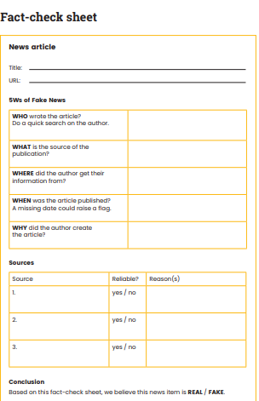

BBC
BBC
Danish News Program
2 December 2021

Inform and Entertain

Dailynews
Youtube
Same news
Video Proof
Same news
9News

